**OrderHistory** [**https://citria.org/profile/order-history**](https://citria.org/profile/order-history)

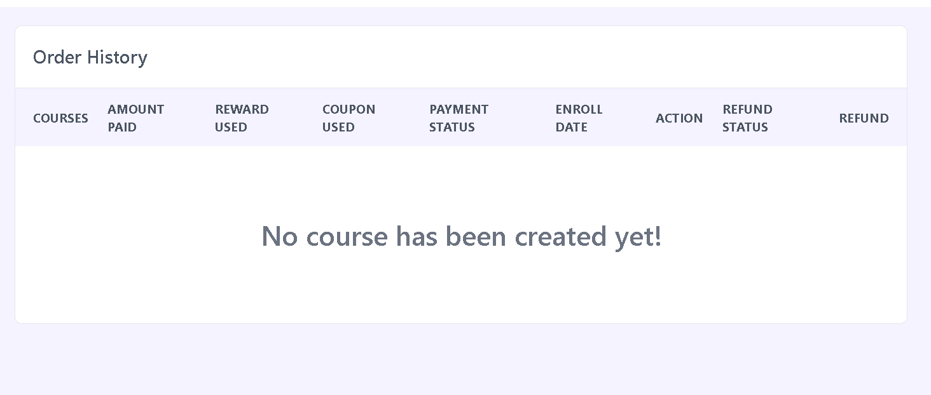

This React component, OrderHistory, displays the order history of enrolled courses. It utilizes various hooks and external components to fetch and present data. Here's a breakdown:

Hooks Used:

useGetEnrolledCourse: Fetches enrolled courses' data.

useGetRefundTerms: Fetches refund terms data.

Table Structure:

The component uses a table to display order history with columns like Courses, Amount Paid, Reward Used, Coupon Used, Payment Status, Enroll Date, Action, Refund Status, and Refund.

It checks for loading state and shows a loading skeleton when data is being fetched.

Refund Handling:

The handleRefundRequest function sends a PATCH request to update the refund status for a specific course based on its ID.

It checks if the refund button should be disabled based on the refund window duration or if a refund has already been requested.

UI Elements:

It utilizes various UI elements like buttons, spans, and conditional rendering based on data conditions.

Styling:

The component employs Tailwind CSS for styling, including classes for layout, spacing, text styling, and button states.

Empty State Handling:

Displays a message when there are no enrolled courses.